LAB 9: File Handling
Part A:
Question 1: Create a File
Write a Python program to create a file named test.txt using mode "x".
Expected message:
File created successfully.

Question 2: Write into a File
Write a Python program to open a file named test.txt and write the following sentence:
Welcome to Python file handling.

Question 3: Write Multiple Lines
Write a Python program to write the following lines into a file named student.txt:
My name is Ali.
I am studying Python.
File handling is useful.

Question 4: Read Whole File
Write a Python program to read and display all the content from student.txt.

Question 5: Read One Line
Write a Python program to read only the first line from student.txt using readline().

Question 6: Read All Lines as List
Write a Python program to read all lines from student.txt using readlines() and display the output.

Part B: Test yourself!
  - Python program to copy the contents from one file to another.
Algorithm:
    - Step 1: Start
    - Step 2: Open the file named “original.txt” in read mode.
    - Step 3: Open another file, “copy.txt” in write mode.
    - Step 4: Read each line from the original file and write it into the copy file.
    - Step 5: Stop
  - Write a program that opens an output file with the filename “my.txt”, writes the name of
animal, some fruit, and your country to the file on separate lines, then close the file.

  - Write a function in python to read the content from a text file "python.txt" line by line and display the same on screen.
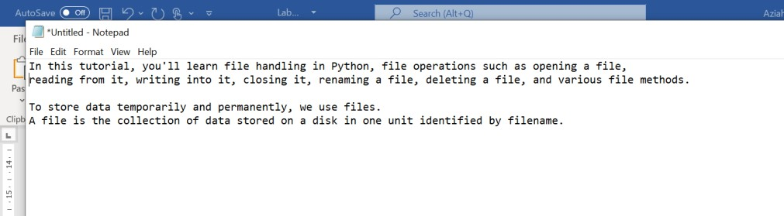
Create a text file and store the lines as below:
  - Write a function in python to count the number of lines from a text file "story.txt" which is not starting with an alphabet "T".
The file "story.txt" should contains any story of yours or you may use the following lines:
Once upon a time, a farmer had a goose that laid a golden egg every day. The egg provided enough money for the farmer and his wife for their day-to-day needs. The farmer and his wife were happy for a long time. But one day, the farmer got an idea and thought, “Why should I take just one egg a day? Why can’t I take all of them at once and make a lot of money?”

5. Copy Only Lines Starting with ‘A’
Write a Python program to read names.txt and copy only the lines starting with A into a_names.txt.
Example names.txt:
Ali
Bala
Anu
Chen
Ameer

Expected a_names.txt:
Ali
Anu
Ameer
- Create a file named marks.txt with the following content:
Ali,80
Bala,65
Chen,90
Devi,55
Write a Python program to display only students who scored more than 70.
Expected output:
Ali scored 80
Chen scored 90

Menu-Driven File Program
Write a menu-driven Python program that allows the user to:
1. Write data into a file
2. Read data from a file
3. Append data into a file
4. Count vowels in the file
5. Exit
Use the file name data.txt.

